
風門 · 第四十二代
M A S T E R W I N D Z

PRE-PURCHASE FENG SHUI AUDIT · 购房前风水审鉴
THE MYST
玄宅 · 风水审鉴报告
A Bilingual Property Analysis of Four Shortlisted Units
四间入围单位之中英文专业风水分析
PREPARED FOR  ［ Client Name 客户姓名 ］ | CONSULTANT  Master Windz 風君子 | DATE  June 2026

SECTION
Table of Contents
目录

I. Introduction to Master Windz
风君子简介
II. Customer Details & Project Overview
客户资料与项目概览
III. Individual BaZi Summary
个人八字命理摘要
IV. Professional Unit Analysis
入围单位专业分析
V. Final Suggestions
最终建议
VI. Disclaimers
免责声明
VII. Master Windz Services
风君子专业服务

ABOUT THIS REPORT · 报告说明
This audit evaluates four shortlisted units at THE MYST Condominium against the BaZi (八字) constitutions of the family and the form & compass feng shui (形势 · 理气) of each unit, to identify the most harmonious choice prior to purchase.
本报告依据贵府家庭成员之八字命理，结合各单位之形势与理气风水，对 THE MYST 四间入围单位进行评估，以助贵府在购房前选定最为相合之居所。

SECTION I
Introduction to Master Windz
风君子简介

A 42nd-generation disciple of the Wind Gate (風門) lineage and a master of feng shui ritual implements, devoted to the authentic transmission of Chinese metaphysics.
Master Windz (風君子) is a Singapore-based practitioner of classical Chinese metaphysics and feng shui. As a forty-second-generation disciple of the Wind Gate lineage (風門), his practice is rooted in the orthodox transmission of the classics rather than popular simplification, integrating the great systems of the art into a single, coherent reading of a person and their space.
风君子，新加坡职业风水与中华玄学执业者，风门第四十二代传人。其学承袭古法正统，融形势与理气于一体，以八字命理为本，参合奇门遁甲、玄空飞星与峦头形势，为客户解读人与居所之气场关系，趋吉避凶。
He is also a master of feng shui ritual implements (風水法器師). From a young age he followed his grandfather, learning the craft hands-on — the selection, consecration and proper placement of sacred artifacts and ritual instruments — a living transmission of skill and technique passed down within the family.
风君子亦为风水法器师。自幼随祖父研习，亲炙其法器之选配、开光与安奉之道，承家学之技艺心法，代代相传，历久弥真。

DISCIPLINES · 所学体系
- Qi Men Dun Jia · 奇门遁甲
- BaZi Destiny Analysis · 八字命理
- Xuan Kong Flying Stars · 玄空飞星
- Form School Feng Shui · 峦头形势
- Sacred Ritual Implements · 风水法器

SCOPE OF ENGAGEMENT · 委托范围
The client has engaged Master Windz to conduct a pre-purchase feng shui audit of four shortlisted units at THE MYST Condominium, assessing each against the family's BaZi and the external & internal feng shui of the development, to recommend the most suitable unit for the household.
客户委托风君子，就 THE MYST 公寓四间入围单位进行购房前风水审鉴，结合家庭八字与项目内外形势理气，择定最适合贵府之单位。

SECTION II
Customer Details & Project Overview
客户资料与项目概览

Household Member · 家庭成员 | Date & Time of Birth · 出生日期时辰 | Zodiac · 生肖
Male Owner · 男主人  ［ Name 姓名 ］ | ［ Date & Time 出生日期时辰 ］ | 属狗 Dog
Female Owner · 女主人  ［ Name 姓名 ］ | ［ Date & Time 出生日期时辰 ］ | 属鼠 Rat
Daughter · 千金  ［ Name 姓名 ］ | ［ Date & Time 出生日期时辰 ］ | 属虎 Tiger

THE PROJECT
Project Orientation · 项目坐向

FACING NORTH 1 · 首选  丙山壬向  Sitting Bing — Facing Ren  - 冲猪 · Clashes the Pig  - 旺丁旺財 · Prospers people & wealth  - 可布「七星打劫」大风水局 · Supports the Seven-Star Robbery grand formation | FACING SOUTH 1  壬山丙向  Sitting Ren — Facing Bing  - 冲蛇 · Clashes the Snake  - 旺丁旺財 · Prospers people & wealth
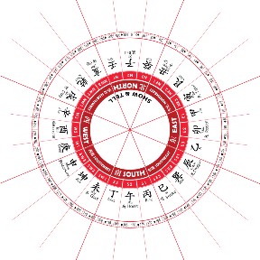
Luo Pan reference · 二十四山罗盘 — Bing/Ren axis governing the development's facing.

SECTION III
Individual BaZi Summary
个人八字命理摘要

Male Owner 男主人 · 属狗 Dog
喜 土 Earth 喜 火 Fire 忌 木 Wood 忌 水 Water
Health tendencies (忌木水): liver & gallbladder, joints, skin, kidneys, stomach weakness, nausea, halitosis, belching, reduced appetite, and the bladder / urinary system (incl. UTI).
注意肝、胆、关节、皮肤、肾、胃虚、恶心、口臭、咯气、食欲减退，以及膀胱等泌尿系统（含尿道感染）。
Female Owner 女主人 · 属鼠 Rat
喜 金 Metal 喜 水 Water 忌 木 Wood 忌 土 Earth
CAUTION YEARS · 注意流年
Major Wood adversity (大木劫) is indicated around ages 38 and 43 — periods calling for prudence in health, partnerships and major commitments.
38 岁与 43 岁有大木劫，宜于健康、合作与重大决策上谨慎守成。

With both Wood and Earth unfavourable, the liver–gallbladder and spleen–stomach systems are the most vulnerable — a tendency to watch, not an inborn defect.
忌木 · Liver–Gallbladder: hepatitis, cholecystitis, fatty liver, gallstones, abnormal liver function; weakening vision, dry/tired eyes, migraine, neuralgia, aching or stiff limbs, joint discomfort, suppressed mood / irritability, poor sleep.
忌土 · Spleen–Stomach: gastritis, ulcers, bloating & acid reflux, stomach pain, indigestion, poor appetite, constipation/diarrhoea, dampness & oedema, muscle weakness, sensitive skin / eczema, lip issues, slow metabolism, easy fatigue.
Daughter 千金 · 属虎 Tiger
喜 水 Water 喜 金 Metal 忌 土 Earth 忌 火 Fire
Health tendencies (忌土火): heart, risk of stroke, blood, athlete's foot, halitosis, toothache, eyes, and the intestinal–stomach digestive system.
注意心脏、脑中风、血液、脚气、口臭、齿痛、眼睛，以及肠胃等消化系统。
CHARACTER · 性格分析
Determined and strong-willed, pressing forward with purpose; quick-witted, capable and far-sighted, working tirelessly toward her goals. Her strength is a firm character with rare patience and perseverance; she can be solitary, serious and cautious, and less inclined toward socialising.
固执，意志坚强，勇往直前；机智能干，眼光长远，努力不懈。优点是个性坚定、极有耐性与毅力；缺点是较孤独、严肃谨慎，不善交际。

SECTION IV
Professional Unit Analysis
入围单位专业分析

The four shortlisted units were assessed against two binding constraints from the family's BaZi: both owners find Wood unfavourable (忌木), so units fronted by trees or forest are penalised; and the development carries recurring structural sha at certain stacks. The findings below summarise external form, internal energy and elemental fit.
四间入围单位以两项关键命理条件为准则评估：男女主人皆忌木，故正前方见树木或林景之单位须扣分；项目部分单位另见结构性形煞。下文综合外形势、内理气与五行相合度。
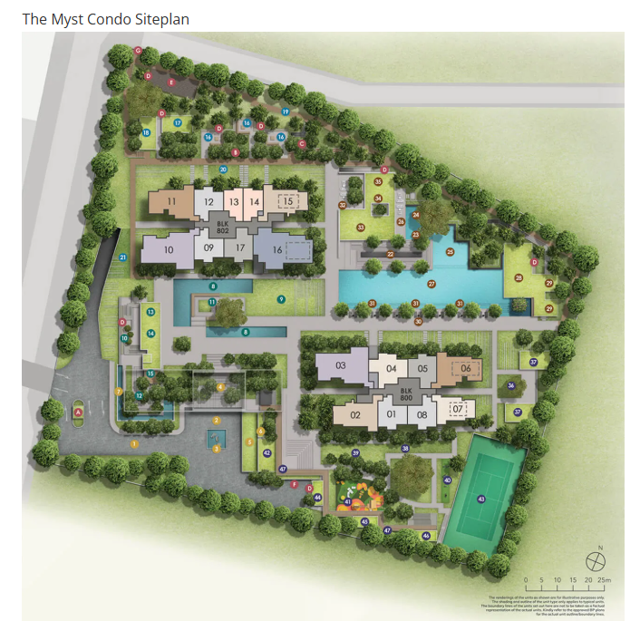
THE MYST site plan · 项目总平面图 — shortlisted stacks: Units 02, 06, 11 & 15.
Unit · 单位 | Verdict · 结论 | Key Reason · 主因
Unit 02 | SKIP | Tree directly in front (忌木) — viable only above level 7.
Unit 11 | SKIP | 忌木 + transformer substation + 火烧天门 + basement qi-leak.
Unit 15 | SKIP | 忌木 + forest frontage + double 火烧天门 + 虎口臭劫 + qi-leak.
Unit 06 | RECOMMENDED | Water-favourable for mother & daughter; balanced with Earth remedy for father.

SECTION IV · CONTINUED
Units Not Advised · 不建议之单位

Unit 02 SKIP · 不建议
忌木 A tree stands directly in front of the unit; as both owners find Wood unfavourable, this frontage works against them. 正前方有树正对，男女主人皆忌木，不利。
条件 Only acceptable if the unit selected is above the 7th floor, lifting the home above the tree line. 除非选择 7 楼以上单位，使居所高于树冠。

Unit 11 SKIP · 不建议
忌木 Unfavourable Wood frontage for both owners. 男女主人皆忌木。
电房 A genset / transformer sub-station footprint sits at the front — affecting both owners' health, particularly sleep and headaches. 前方有发电机／变电站之占位，影响二人健康，尤以睡眠与头痛为甚。
火烧天门 Fire Burning the Heaven's Gate — afflicts the male owner's career. 「火烧天门」之象，影响男主人事业。
漏财 A front ventilation shaft connects down to the basement. The dragon side (front-left of the entrance) governs vitality, benefactors and wealth and should be bright, open and rising; an underground qi-mouth is read as a qi-leak / wealth-leak. 前方通风井下连地库；龙边主生气、贵人、财运，宜明亮向上，地下气口属泄气漏财之象。

Unit 15 SKIP · 不建议
忌木 Faces the forest lounge — strong Wood frontage, unfavourable for both owners. 正对森林休憩区，木气重，二人皆忌木。
火烧天门 Double Fire-Burning-Heaven's-Gate affliction. 双重「火烧天门」之象。
虎口臭劫 A refuse / bin centre at the front area (Tiger's-Mouth foul affliction) — affecting the female occupant in particular. 前方设垃圾收集中心（虎口臭劫），尤其影响女性居住者。
漏财 Front ventilation shaft connecting to the basement — the same dragon-side qi-leak / wealth-leak. 前方通风井下连地库，同属龙边泄气漏财之象。

SECTION IV · RECOMMENDED
Unit 06 — The Recommended Choice · 单位 06 · 唯一首选

Unit 06 RECOMMENDED · 唯一首选
坐向 丙山壬向 · 冲猪 · 旺丁旺財 — and able to host the 「七星打劫」 grand feng shui formation. 坐丙向壬，冲猪，旺丁旺财，可布「七星打劫」大风水局。
喜水 Both the female owner and daughter find Water favourable (喜水) — the unit suits them well. 女主人与千金皆喜水，此单位对二人甚为有利。
父忌水 The father finds Water unfavourable (忌水); his personal Earth-element feng shui must be enhanced to balance this. 男主人忌水，须加强其个人之土元素风水化解。

SELECTION CONDITION · 选购条件
Select a stack above the 7th floor to clear surrounding tree lines and secure clean, open Bright Hall (明堂) energy.
务必选择 7 楼以上之单位，以越过周边树冠，确保明堂开阔清气。
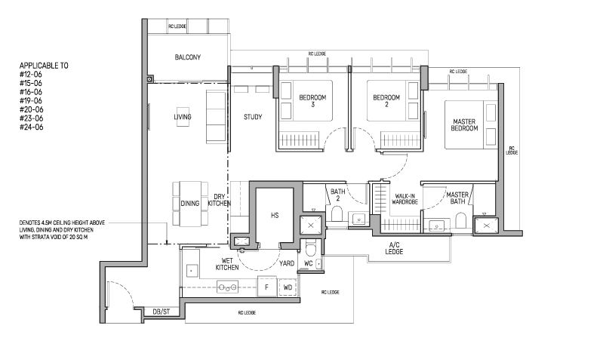
Unit 06 floor plan · 单位 06 户型图 (applicable to #12-06, #15-06, #16-06, #19-06, #20-06, #23-06, #24-06).
North Protruding Corner · 北方凸角
Unit 06 carries a protruding corner in the North. In classical feng shui the North is the Kan Gua (坎卦), element Water, governing career, life path, wealth flow, the middle son, the kidneys, bladder and ears, and overall emotional stability.
单位 06 北方有凸角。北方属坎卦、五行属水，主事业、人生道路、财气流动、中男，并主肾、膀胱、耳与情绪之稳定。
CROSS-REFERENCE · 命理互参
The male owner's BaZi already flags a kidney & bladder tendency. As this North Water palace resonates with the same organs, an Earth-element remedy here serves the household twice over — balancing his 忌水 and steadying the Water palace. On-site verification of this corner is advised before commitment.
男主人八字本已显肾、膀胱之倾向，而北方水宫正应此脏腑；于此布土制水，一举两用——既化其忌水，又稳水宫之气。建议购房前到场实测此凸角。

SECTION V
Final Suggestions
最终建议

No. | Recommendation · 建议
01 | Choose Unit 06, above level 7 — the only stack of the four that aligns with the family's elements without disqualifying external sha.  选定单位 06，且为 7 楼以上 — 四者之中唯一五行相合、无致命外煞之选。
02 | Favour the 丙山壬向 (Facing North 1) orientation where available, enabling the 「七星打劫」 grand formation for prosperity of people and wealth.  优先 丙山壬向 之坐向，以布「七星打劫」大局，旺丁旺财。
03 | Install a personal Earth-element remedy for the father (忌水), concentrated at the North Water palace / protruding corner.  为男主人布个人土元素化解，集中于北方水宫／凸角，化忌水、稳水气。
04 | Minimise heavy Wood elements (large plants, dense timber, forest-facing openings) in shared living areas, as both owners find Wood unfavourable.  公共起居空间宜减少重木元素（大型植栽、密集木作、正对林景之开口），二人皆忌木。
05 | Support the family's health sectors through placement — easing the liver/gallbladder & spleen/stomach tendencies of the female owner and the kidney/bladder tendency of the male owner.  以布局调养家庭健康宫位——疏缓女主人肝胆脾胃、男主人肾膀胱之倾向。
06 | Observe the female owner's caution years (ages 38 & 43) with prudent timing for major decisions and renovation.  留意女主人 38 与 43 岁之大木劫流年，重大决策与装修宜择吉而行。
07 | Confirm with an on-site Luo Pan reading before signing — to verify the exact facing degree and the North corner before purchase is committed.  签约前宜到场以罗盘实测，确认精确坐向与北方凸角。

IN SUMMARY · 总结
Of the four shortlisted units, Unit 06 (above level 7) is the singular recommendation. Units 02, 11 and 15 each carry Wood-conflict frontage and structural sha that work against this household. With the right orientation and a tailored Earth remedy for the male owner, Unit 06 offers the family a harmonious, prosperous home.
四者之中，单位 06（7 楼以上）为唯一推荐。02、11、15 皆见忌木正对与结构形煞，不利贵府。配以合宜坐向与为男主人量身之土元素化解，单位 06 可成贵府和顺旺达之居。

SECTION VI
Disclaimers
免责声明

- This report is prepared by Master Windz for the private reference of the named client and reflects the practice of traditional Chinese metaphysics and feng shui as a cultural and advisory art.
本报告由风君子为指定客户私人参考而制，乃传统中华玄学与风水之文化咨询，仅供参考。
- It does not constitute medical, psychological, legal, financial or investment advice. References to health, organs or illness describe traditional five-element correspondences only and are not a diagnosis or treatment plan; please consult a qualified medical professional for any health concern.
本报告不构成医疗、心理、法律、财务或投资建议。文中健康、脏腑、疾病之内容仅为传统五行对应之说，绝非诊断或治疗方案，任何健康问题请咨询合格医师。
- Property purchase decisions involve financial, legal and personal factors beyond feng shui. Master Windz is not a licensed property, financial or legal adviser; please seek the relevant licensed professionals, and treat this audit as one consideration among many.
购房涉及风水以外之财务、法律与个人因素。风君子非持牌房产、财务或法律顾问，请另行咨询相关持牌专业人士，本审鉴仅为众多考量之一。
- The analysis depends on the accuracy of the birth data and unit information provided. Should any detail differ — including exact birth times or the final facing degree measured on site — conclusions may be revised.
分析以所提供之出生资料与单位信息为准；如有出入（含确切出生时辰或现场实测坐向），结论或须修订。
- All recommendations are advisory. The final decision and its outcomes rest entirely with the client.
所有建议仅供参考，最终决定及其结果概由客户自行承担。

SECTION VII
Master Windz Services
风君子专业服务

Beyond pre-purchase audits, Master Windz offers the full range of classical metaphysics services for home, business and life events. 除购房前审鉴外，风君子提供居家、商业与人生大事之全方位中华玄学服务。
阳宅风水  Property & Space Feng Shui  Residential & commercial audits — site selection, layout, renovation & activation. | 八字命理  BaZi Destiny Reading  Personal destiny analysis, luck cycles, career, wealth & relationships.
奇门遁甲  Qi Men Dun Jia  Strategic forecasting & decision timing for business and key undertakings. | 玄空飞星  Flying Stars Analysis  Period & annual star charting with tailored remedies.
择日选时  Auspicious Date Selection  Weddings, move-ins, openings, ground-breaking & ceremonies. | 法會祈福  Ritual Ceremonies  Blessing rituals & ceremonies for protection, fortune & harmony.
课程工作坊  Workshops & Courses  Guided learning in feng shui & Chinese metaphysics for enthusiasts. | 法器圣物  Sacred Artifact Consultation  Selection, consecration & placement of feng shui items & ritual objects.

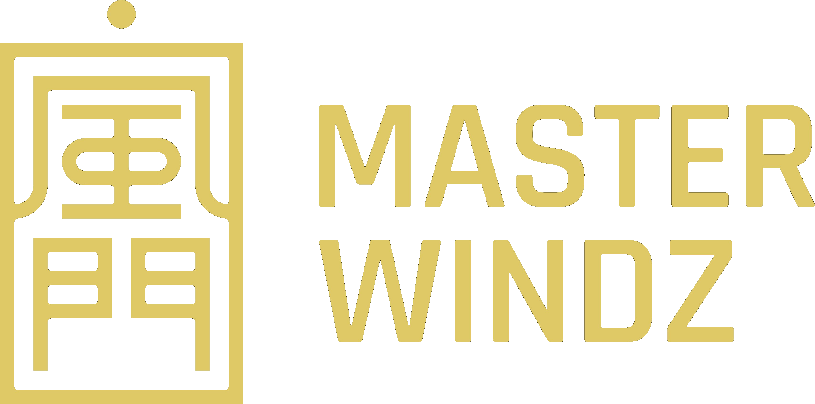
风门第四十二代 · 风君子
Authentic Chinese Metaphysics · Singapore
Consult Master Windz 風君子
© 2026 Master Windz · This report is confidential and prepared for the named client.

